## Ms Web Tech Assignment 1 – MVC Basics

In this assignment, you are working on a site for OEC, a fertilizer company. You need to create the database from a script, generate the models and create views to display and maintain the *crop* & *fertilizer* tables. In this assignment and all subsequent assignments, whenever you see “XX”, replace it with your initials.

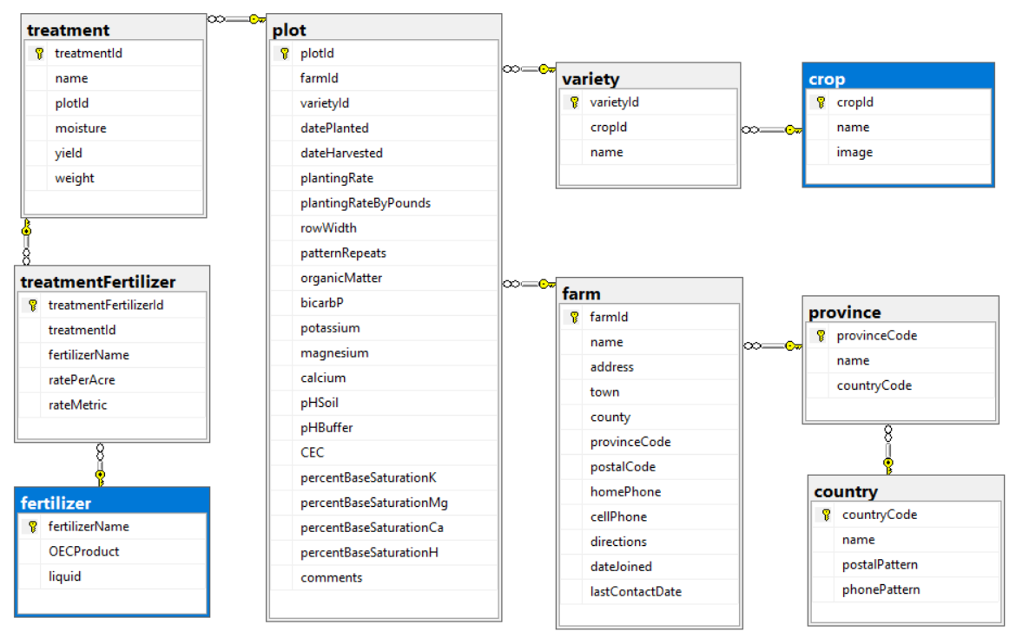

## XXOEC project

1. Create an ASP.NET Core project based on .NET Core and using the MVC (Core) technique. Call it ***XXOEC*** (where XX are your initials).
   1. Remember to ***Change Authentication*** to ***Individual User Accounts*** … otherwise, you don’t get Entity Framework support for your database.
2. Load the database to SQL, then generate the models & context for Entity Framework:
   1. Download the ***OEC.sql*** database script from the course site
   2. Use SQL Server Management Studio Express to execute the script and build the database.
   3. Generate the Entity Framework classes for the database in the project’s Models folder. Name the context ***OECContext***.
   4. Add the connection string to ***appsettings.json***, add a service to ***Startup.cs*** to support dependency injection for the context, and add a constructor in the context to load the connection string via a DbContextOptions collection.
3. Modify the default layout’s footer:
   1. Put your name and section on the left side of the footer. Your name should be a hyperlink causing the user’s e-mail client to create an email to your college e-mail account.
   2. Move the menu’s hyperlinks for “About” and “Contact” to the right side of the footer, retaining the horizontal alignment.

## XXCropController

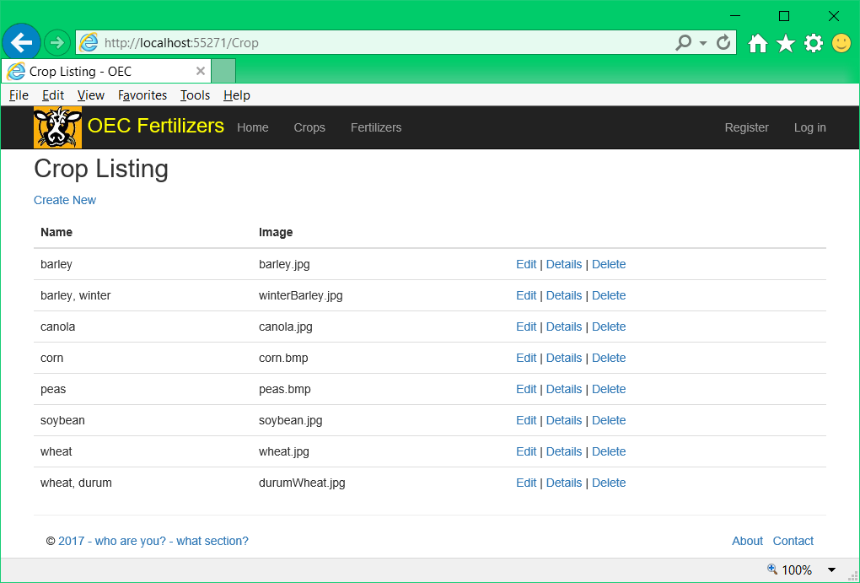

1. Generate a controller called **XXCropController** along with the required Views to enable full CRUD maintenance on the *Crop* table. Add a link to it on the menu.
   1. Ensure all views & hyperlinks function correctly
   2. Change the browser window title and the heading on the Index view to “Crop Listing” instead of “Index” … less ambiguity for the user this way.
2. Change the browser titles and headings on the Details, Create, Edit and Delete views as well, to reference the table being modified (“Edit Crop”, etc.).

## XXFertilizerController

1. Generate a controller called **XXFertilizerController** along with the required Views to enable full CRUD maintenance on the *fertilizer* table. Add a link for this controller to the menu.
   1. The key, *fertilizerName,* is manually entered.
      1. It should be displayed on all Views, but it can only be modified on the Create View. Go to the *Crop* views to see how a string field is handled.
      2. Watch for “*string?”* in the action parameters … this is a generated fault you need to fix.
   2. Again, modify the browser title and page headings on the views to mention the table being displayed or modified.

## Both Controllers

1. Ensure the controllers, their menu entries, and their actions all work.
2. Comments are required to describe what the program does and what each of its actions do. Generated controllers have 9 methods (actions). At 1% each, that’s a 10% penalty for each controller.

## Hand In

1. Zip and upload your project folder to the [D2L Drop-Box](https://www.econestoga.ca) (course tools 🡪 assignments) for this assignment.
2. Print and hand in [the marking sheet](http://econestoga.ca) (Content 🡪 assignments) with your name, section & your instructor’s name on it.